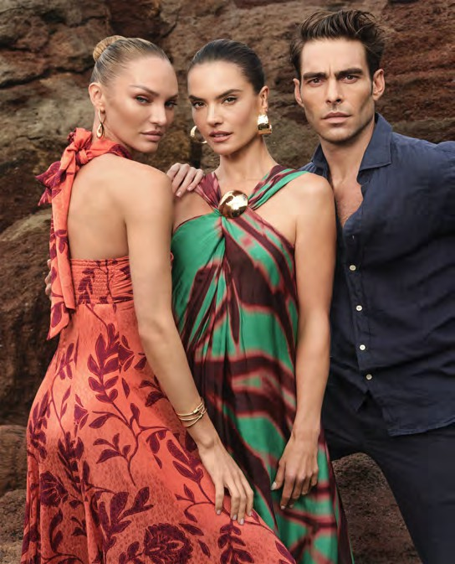
PRESS RELEASE

El Corte Inglés presents its new spring campaign with Alessandra Ambrosio, Candice Swanepoel and Jon Kortajarena
- With its emblematic claim "Ya es primavera” (Spring is here), El Corte Inglés welcomes one of the most awaited seasons of the year.
- Intense red, black and white, pastel and earthy colours and prints are the stars of the new collections of El Corte Inglés' own brands.

Madrid, 13 March 2025: El Corte Inglés presents its new fashion campaign "Ya es primavera" with models Alessandra Ambrosio and Candice Swanepoel as ambassadors and with the special collaboration of Spanish actor and model Jon Kortajarena.

The El Corte Inglés fashion campaign ad shows a more organic, purer, wilder and at the same time the most unexpected spring. Incomparable landscapes of Lanzarote serve as a backdrop to showcase the new collections. A fashion show in a unique universe with a surrealist and mysterious tone, in which the elements of nature are enveloped in the colours, light and textures of the island and fused with the must-have fashions for this season.

El Corte Inglés creates fashion for this spring with its own brands for women: Woman, Woman Limited, Lloyd's, Tintoretto, Sfera, Jo&Mr.Joe and Latouche, and for men: Emidio Tucci and Dustin. All of them are available in its shops, in its shopping app and on its website www.elcorteingles.es.

"Ya es Primavera" will feature digital media, outdoor advertising, magazines and 60", 30" and 20" ads. The campaign has been developed by El Corte Inglés' in-house teams together with the production company CAP and the photographer Txema Yeste. The theme song is Eusexua by FKA Twigs.

